SIMATS ENGINEERING
SAVEETHA INSTITUTE OF MEDICAL AND TECHNICAL SCIENCES
CHENNAI – 602105
Department of Computer Science and Engineering

ASSESSMENT TOOL 2 – CLASS TEST - 02

Course Code: | DSA05 | Course Title: | Query Processing for Data Science in Real Time Applications
CO Assessed: | CO4 | Assessment: | Tool 2 – Class Test - 02
Weightage: |  | Total Marks: | 25 Marks
CO4 Statement: Explore datasets using analytical techniques such as grouping, correlation detection, joining datasets, and extracting meaningful insights.. (BL4 and BL5)
Student Name: | Veda Krishnan V A | Reg. No.: | 192324293
Section / Batch: | A 2023 | Date of Submission: | 31– 08 – 2026
Faculty In-charge: | K.Veena devi | Assessment Mode: | Individual Submission

Q1  (5 Marks) | Q2  (5 Marks) | Q3  (5 Marks) | Q4  (5 Marks) | Q5  (5 Marks) | Total (25 Marks)

- A customer database contains inconsistent date formats (DD/MM/YYYY and MM-DD-YYYY), duplicate customer records, and missing phone numbers.

Explain the sequence of data-cleaning steps you would perform to prepare the dataset for analysis. Justify why each step is necessary and discuss the potential impact of skipping any one of these steps.

Sequence of steps:
  - Standardize Date Formats: Standardizing to a unified format (e.g., YYYY-MM-DD) is necessary to ensure temporal analysis and sorting work correctly. Skipping this leads to broken time-series operations and aggregation errors.
  - Remove Duplicates: Identify duplicates using unique keys like CustomerID or Email and drop them. This is crucial because duplicates artificially inflate counts and skew metrics.
  - Handle Missing Phone Numbers: Impute with a placeholder (e.g., 'Not Provided') or drop if phone is strictly required for the analysis. Skipping this can cause downstream algorithm failures or biased targeting.

import pandas as pd

# Assuming df is our dataframe
# 1. Standardize dates with mixed format inference df['Date'] = pd.to_datetime(df['Date'], format='mixed')

# 2. Remove duplicate customer records
df = df.drop_duplicates(subset=['CustomerID'])

# 3. Handle missing phone numbers df['Phone'] = df['Phone'].fillna('Not Provided')

- A retail sales dataset contains monthly sales values ranging from ₹10,000 to ₹500,000, except for one record showing sales of ₹15,000,000.

Analyze whether this value should be treated as an outlier. Describe the methods you would use to verify it and explain how keeping or removing it could affect subsequent data analysis.

Analysis:
Yes, ₹15,000,000 is statistically an outlier, but it might not be an error (could be a bulk corporate order).
Methods to verify:
- Statistical: Use the Interquartile Range (IQR) method or Z-score to mathematically flag it.
- Contextual: Check related fields (e.g., 'Customer Type', 'Items Sold') to see if the large total makes sense.
Impact:
- Keeping it: Will drastically skew the mean and variance, making predictive models biased toward this high value.
- Removing it: Restores normal distribution but risks losing valid insights into high-value wholesale transactions.

import pandas as pd import numpy as np

# 1. IQR Method for outlier detection Q1 = df['Sales'].quantile(0.25)
Q3 = df['Sales'].quantile(0.75)
IQR = Q3 - Q1
upper_bound = Q3 + 1.5 * IQR

outliers = df[df['Sales'] > upper_bound] print(f'Identified Outliers:\n{outliers}')
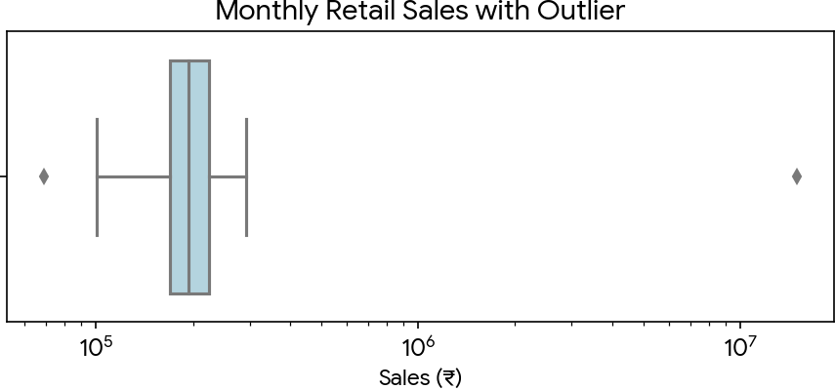
- An organization has customer names recorded as: John Smith
Jon Smith
J. Smith John Smithe

and email addresses that must follow the format name@company.com.

Compare how Fuzzy Matching and Regular Expression (RegEx) Matching can be used in this situation. Explain which technique is more suitable for name matching and which is more suitable for email validation, with reasons.

Comparison:
Fuzzy Matching calculates the similarity score (e.g., Levenshtein distance) between two strings, making it highly tolerant to typos, phonetic spelling, and abbreviations. It is the MOST suitable technique for name matching because human names lack a strict standard structure and frequently contain spelling variations ('Jon' vs 'John').

Regular Expression (RegEx) enforces strict pattern matching based on defined rules. It is MOST suitable for email validation because emails have a highly predictable, standardized syntax (username + @ + domain + .com). RegEx quickly identifies invalid structures but is too rigid for handling misspelled names.

import re

from fuzzywuzzy import fuzz

# Fuzzy Matching for Names

name1, name2 = 'John Smith', 'Jon Smith' similarity = fuzz.ratio(name1, name2) print(f'Similarity Score: {similarity}%')

# RegEx for Email Validation email = 'john.smith@company.com'
pattern = r'^[a-zA-Z0-9._%+-]+@company\.com$' if re.match(pattern, email):
print('Valid Corporate Email')
- A company wants to understand the relationship between advertising expenditure and product sales across different regions.

Describe how you would explore the dataset to identify correlations. What visualizations would you use, and how would you interpret a strong positive, weak, or negative correlation in this context?

Exploration & Visualizations: I would use a Scatter Plot with a regression trendline to visually inspect the relationship. I would also calculate the Pearson Correlation Coefficient (r) to quantify it.

Interpretation:
- Strong Positive Correlation (r > 0.7): As advertising spend increases, sales increase proportionally. The ad campaign is highly effective.
- Weak Correlation (r near 0): Changes in advertising spend have little to no effect on sales. The marketing strategy may need a redesign.
- Negative Correlation (r < 0): As ad spend increases, sales decrease. This is rare but could indicate ad fatigue, alienating campaigns, or external factors dominating.

import pandas as pd import seaborn as sns
import matplotlib.pyplot as plt

# Calculate Pearson Correlation

corr = df['Ad_Expenditure'].corr(df['Product_Sales']) print(f'Correlation Coefficient: {corr:.2f}')

# Visualization

sns.regplot(x='Ad_Expenditure', y='Product_Sales', data=df)
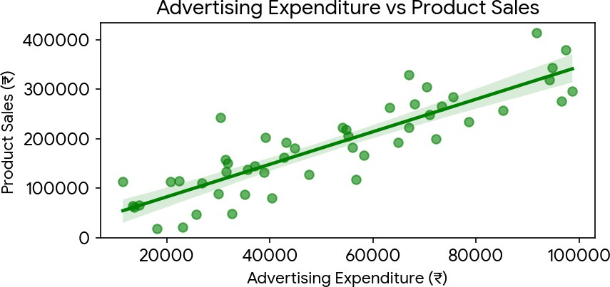
plt.show()
- A city administration has collected data on: Monthly traffic volume
Accident locations
Population distribution across zones Public feedback comments
Recommend the most appropriate visualization technique for each type of data (chart, map, word cloud, etc.). Justify your choices and explain how they help decision-makers understand the information effectively.

Recommendations:
  - Monthly traffic volume: Line Chart. It excels at displaying trends over time, helping officials spot peak months and seasonal patterns.
  - Accident locations: Geospatial Heatmap or Point Map. Maps plot exact latitude/longitude, immediately highlighting dangerous intersections and accident clusters for infrastructure repair.
  - Population distribution across zones: Choropleth Map or Bar Chart. A choropleth map color-codes zones by density, intuitively showing crowded areas, while a bar chart offers precise comparative metrics between zones.
  - Public feedback comments: Word Cloud or Sentiment Analysis Bar Chart. Word clouds visualize the most frequent terms (e.g., 'potholes', 'delays'), providing instant insight into primary citizen concerns without reading thousands of texts.

import matplotlib.pyplot as plt

from wordcloud import WordCloud

# Example: Generating a Word Cloud for feedback

feedback_text = 'traffic delay pothole noise pollution pothole traffic accident speed'

wordcloud = WordCloud(width=800, height=400, background_color='white').generate(feedback_text)

plt.figure(figsize=(8, 4)) plt.imshow(wordcloud, interpolation='bilinear') plt.axis('off')
plt.title('Public Feedback Word Cloud') plt.show()

